

Republic of the Philippines
Department of Education
Region VI – Western Visayas
DIVISION OF AKLAN
Numancia, Aklan

REQUEST FOR QUOTATION (RFQ)
Project No: DepED-RO6-D1-CID-LCPSUPPLIES-052-2020

The Department of Education Division of Aklan, through its Bids and Awards Committee (BAC) invites the suppliers to submit quotation and to bid for the hereunder list of procurement:

NAME OF PROJECT: | Procurement of materials for the Reproduction of Modules for the opening of Classes SY 2020-2021
FUNDING SOURCE: | GOVERNMENT OF THE PHILIPPINES (GOP) 2020 Downloaded Fund
APPROVED BUDGET  FOR THE CONTRACT: | Php458,100.00
CONTRACT DURATION: | 15 Calendar Days
MODE OF PROCUREMENT: | Negotiated – Small Value Procurement (Section 53.9)

The Department of Education Division of Aklan, through its Bids and Awards Committee (BAC), now invites bids for the above-mentioned works.

The Schedule of BAC Activities is as follows:

Activity | Date and Time | Venue
Issuance of Canvass | July 20 - 23, 2020, 2020  8:00 AM – 5:00 PM | DepED Division of Aklan
Pre-Bid Conference | Not applicable
Submission & Receipt of Canvass | On or July 23, 2020  5:00 PM | DepED Division of Aklan

DepED reserves the right to accept or reject any or all canvasses, to annul the bidding process, or declare failure of procurement at any time prior to contract award without thereby incurring any liability to the affected parties.

For further information, please refer to:

EDSELYN T. BIRAY
Secretariat
Bids and Awards Committee (BAC)
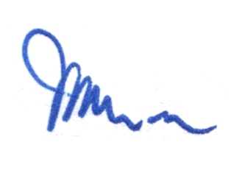
Department of Education, Division of Aklan
Arch. Bishop Reyes St., Kalibo, Aklan
Telephone No. (036) 268-6286

JOSE NIRO R. NILLASCA
BAC Chairperson

