
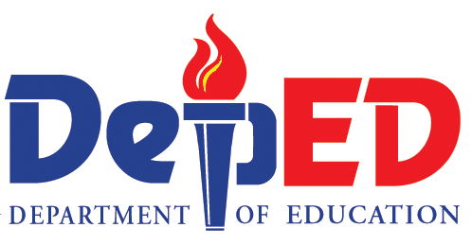
Republic of the Philippines
Department of Education
Region VI – Western Visayas
SCHOOLS DIVISION OF AKLAN
Numancia, Aklan

REQUEST FOR QUOTATION (RFQ)
Project No: DepED-RO6-D1-SGOD(BrigadaEskwela2020)-045-2021

The Department of Education Schools Division of Aklan, through its Bids and Awards Committee (BAC) invites the suppliers to submit quotation and to bid for the hereunder list of procurement:

Name of Project: | Lease of Real Property and Venue with Catering Services for the conduct of Brigada Eskwela Best Implementing Schools 2020 Awarding Program
Funding Source: | GOVERNMENT OF THE PHILIPPINES (GoP) 2021
Approved budget  for the contract: | Php80,000.00
Date of Activity : | November 5 2021
Participants: | 100 participants
MODE OF PROCUREMENT: | NEGOTIATED-SMALL VALUE PROCUREMENT (SECTION 53.9)

The Department of Education Schools Division of Aklan, through its Bids and Awards Committee (BAC), now invites bids for the above-mentioned works.

Proposed Menu:
For AM and PM Snacks:
Juice/Bottled Water, Any of Soup with Toasted Bread/
Cakes, Sandwiches/Hamburger/Siopao/Pasta
For Lunch:
Rice, Main Dish (2), Side Dish (1), Desserts/Fruits,
Soup, Juices/Bottled Water
* No Serving of Softdrinks and/or artificially-flavored drinks
* No pork
* Fresh Fruits for Desserts
* Bottled Water (250ml)
* Provision of Venue with Tables and Chairs and other Amenities
* Overflowing Coffee
* November 5, 2021 - 100 pax Complete Meal
* Provision of Triad in before entering the Hall
* Can Accommodate 30% of the Total Capacity of the Venue
in Compliance with the Guidelines of IATF
* Provision of Sound System and Lights
* Free use of Venue for Preparation for Stage Decoration
* Free Parking space in the vicinity of the venue

The Schedule of BAC Activities are as follows:

Activity | Date and Time | Venue
Issuance of Canvass | September 20-23, 2021  8:00 AM – 5:00 PM | DepED Division of Aklan
Pre-Bid Conference | Not applicable
Submission & Receipt of Canvass | On or Before September 23, 2021  5:00 PM | DepED Division of Aklan
DepED reserves the right to accept or reject any or all canvasses, to annul the procurement process, or declare failure of procurement at any time prior to contract award without thereby incurring any liability to the affected parties.

For further information, please refer to:
EDSELYN T. BIRAY
Secretariat
Bids and Awards Committee (BAC)
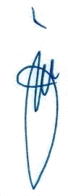
Department of Education, Schools Division of Aklan,
Poblacion, Numancia, Aklan,
Telephone No. (036) 265-3744 local 109

JERSON B. LABOS EdD
BAC Chairperson

